CNSL Lab Assignment 5
Neeti Kurulkar
Write a program to demonstrate Sub-netting and find subnet masks.

Code :

import java.util.Scanner;
import java.net.InetAddress;

public class cnl_5a {
public static void main(String args[]){
Scanner sc = new Scanner(System.in);
System.out.print("Enter IP Address: ");
String ip = sc.nextLine();
String split_ip[] = ip.split("\\."); //split the ip address

//convert IP Adress to binary
String split_bip[]= new String[4];
String bip = "";
for(int i=0;i<4;i++) {
split_bip[i] = appendZeroes(Integer.toBinaryString(Integer.parseInt(split_ip[i])));
bip += split_bip[i];
}
System.out.println("Binary IP Address: " + bip);

//find subnet mask
System.out.print("\nEnter the number of address: ");
int n = sc.nextInt();
int bits = (int)Math.ceil(Math.log(n) / Math.log(2));
System.out.println("\nThe number of bits required = " + bits);
int mask = 32 - bits;
int total_address = (int)Math.pow(2, bits);
System.out.println("Subnet mask is : " + mask);

//Calculate First Address
int fbip[] = new int[32];
for(int i = 0; i < 32; i++){
fbip[i] = (int)bip.charAt(i) - 48; //convert char -> int
}
for(int i = 31; i > (31 - bits); i--){
//Get first address by ANDing the last bits with 0
fbip[i] &= 0;
}
String fip[]={"","","",""};
for(int i = 0; i < 32; i++){
fip[i/8] = new String(fip[i/8] + fbip[i]);
}
int first_offset = 0;
int ipAddr[] = new int[4]; ;
System.out.println("\nGroup 1 \nThe First Address is:");
for(int i = 0; i < 4; i++){
System.out.print(ipAddr[i] = first_offset = Integer.parseInt(fip[i], 2));
if(i != 3)
System.out.print(".");
}
System.out.println();

//Calculate Last Address
int lbip[] = new int [32];
for(int i = 0; i < 32; i++){
lbip[i] = (int)bip.charAt(i) - 48; //convert char -> int
}
for(int i = 31; i > (31 - bits); i--){
// Get last address by ORing last bits with 1
lbip[i] |= 1;
}
String lip[] = {"","","",""};
for(int i = 0; i < 32; i++){
lip[i/8] = new String(lip[i/8] + lbip[i]);
}
int ipLast[] = new int[4];
System.out.println("The Last Address is: ");
for(int i = 0; i < 4; i++){
System.out.print(ipLast[i] = Integer.parseInt(lip[i], 2));
if(i != 3)
System.out.print(".");
}
System.out.println();

System.out.println("\nHow many subnets do you want to form?");
int scount = sc.nextInt();
for(int j = 1; j < scount; j++){
System.out.println("\nGROUP " + (j+1) + " FIRST ADDRESS:");
for(int i = 0; i < 4; i++){
if(i < 3)
System.out.print(ipAddr[i] + ".");
else
System.out.println(ipAddr[i]= ipAddr[i] + total_address);
}
System.out.println("GROUP "+ (j+1)+" LAST ADDRESS:");
for(int i = 0; i < 4; i++){
if(i < 3)
System.out.print(ipLast[i]+".");
else
System.out.println(ipLast[i] = ipLast[i] + total_address);
}
System.out.println();
}

//Ping another IP Address
try{
System.out.println("Enter the Ip address to ping: ");
Scanner s = new Scanner(System.in);
String ip_add = s.nextLine();
InetAddress inet = InetAddress.getByName(ip_add);
if(inet.isReachable(5000))
System.out.println("The ip address is reachable" + ip_add);
else
System.out.println("The ip address is not reachable "+ip_add);

}
catch( Exception e){
System.out.println("Exception:" + e.getMessage());
}
}

//function
static String appendZeroes(String s){
String temp = new String("00000000");
return temp.substring(s.length()) + s;
}
}

Output:
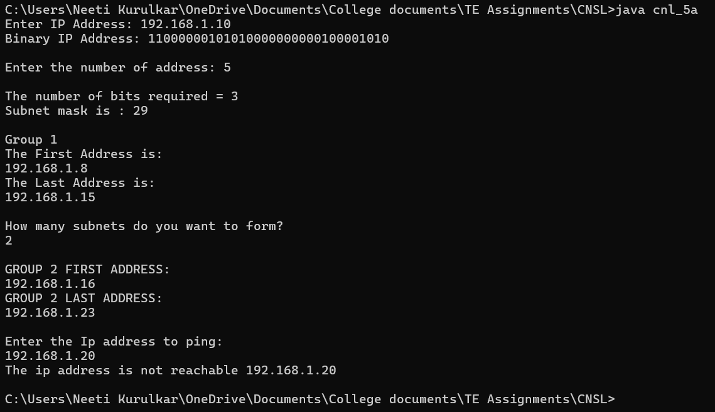

import java.util.Scanner;

public class cnl_5b {
public static void main(String[] args) {
Scanner scan = new Scanner(System.in);
String ip = new String();
int mask = 0, defaultmask = 0;
System.out.println("enter ip address");
ip = scan.nextLine();
System.out.println("enter mask");
mask = scan.nextInt();
String[] splitip = ip.split("\\.");
System.out.println(splitip[0] + " " + splitip[1] + " " + splitip[2] + " " + splitip[3] + " ");
int first = Integer.parseInt(splitip[0]);

if(first >= 0 && first <= 127){
System.out.println("CLASS A");
defaultmask = 8;
}
else if(first > 127 && first <= 191){
System.out.println("CLASS B");
defaultmask = 16;
}
else if(first > 191 && first <= 223){
System.out.println("CLASS C");
defaultmask = 24;
}
else if(first > 223){
System.out.println("CLASS D");
defaultmask = 32;
}

String binip = new String();
String defmask = new String();
for(int i=0;i<4;i++){
binip = binip + appendZeroes(Integer.toBinaryString(Integer.parseInt(splitip[i])));
}

System.out.println("IP in binary : " + binip);
System.out.println("Default Mask : " + defaultmask);

for(int i=0;i<32;i++){
if(i<mask)
defmask = defmask + "1";
else
defmask = defmask + "0";
}
System.out.println(defmask);

String netid = new String();
for(int i=0;i<32;i++){
netid = netid +
(Integer.parseInt(""+binip.charAt(i))&Integer.parseInt(""+defmask.charAt(i)));
}

int p=-1;
System.out.println(netid);
String[] net = new String[4];
String[] def = new String[4];

for(int i = 0; i < 32; i++){
if((i % 8) == 0){
p++;
net[p] = "";
def[p]="";
net[p] = net[p] + netid.charAt(i);
def[p] = def[p] + defmask.charAt(i);
}
else{
net[p] = net[p] + netid.charAt(i);
def[p] = def[p] + defmask.charAt(i);
}
}

System.out.println("Given IP : "+ip);
System.out.print("subnet mask : ");
for(int i=0;i<4;i++){
System.out.print(Integer.parseInt(def[i],2));
if(i!=3)
System.out.print(".");
}
System.out.println();

System.out.print("NetId : ");

for(int i = 0; i < 4; i++){
System.out.print(Integer.parseInt(net[i], 2));
if(i != 3)
System.out.print(".");
}
}

private static String appendZeroes(String binaryString) {
String temp = new String("00000000");
return temp.substring(binaryString.length())+ binaryString;
}
}

Output:
